KAVACH – A Mobile Application for Newborn Health Record & Vaccination Management
A Project Report
Submitted in partial fulfilment of the
requirements for the award of the Degree of
BACHELOR OF SCIENCE (INFORMATION TECHNOLOGY)
By
Piyush Nityanand Nirmal
Under the esteemed guidance of
Mr.Rajendra Patole
Assistant Professor, Department of Information Technology
And Data Science


DEPARTMENT OF INFORMATION TECHNOLOGY AND DATA SCIENCE
VIDYALANKAR SCHOOL OF INFORMATION TECHNOLOGY
(Affiliated to University of Mumbai)
MUMBAI, 400 037
MAHARASHTRA
2025 - 2026

VIDYALANKAR SCHOOL OF INFORMATION TECHNOLOGY
(Affiliated to University of Mumbai)
MUMBAI-MAHARASHTRA-400037

DEPARTMENT OF INFORMATION TECHNOLOGY
AND DATA SCIENCE

CERTIFICATE
This is to certify that the project entitled, " KAVACH – A Mobile Application for Newborn Health Record & Vaccination Management ", is bonafied work of Piyush Nityanand Nirmal bearing Seat No: 23302A0023 submitted in partial fulfilment of the requirements for the award of degree of BACHELOR OF SCIENCE in INFORMATION TECHNOLOGY from University of Mumbai.

Internal Guide Coordinator

Internal Examiner External Examiner

Date: College Seal Principal

- COMPANY CERTIFICATE (for LIVE Project)
- Avishkar/ Tantravihar/ Project Exhibition CERTIFICATE
- Vsearch/ National/ International level Conference CERTIFICATE
- RESEARCH PAPER

ABSTRACT

This project is a child health tracker web app that lets doctors, parents, and hospitals register details, track vaccinations, and generate certificates using easy forms. All data is stored in the browser, and certificates can be downloaded as PDFs.This is a child health tracker web app where doctors, parents, and children can register their details, vaccination status is tracked, and certificates can be generated and downloaded as PDFs—all data is saved in the browser for quick access.

ACKNOWLEDGEMENT

This project is a child health tracker web app that lets doctors, parents, and hospitals register details, track vaccinations, and generate certificates using easy forms. All data is stored in the browser, and certificates can be downloaded as PDFs. This is a child health tracker web app where doctors, parents, and children can register their details, vaccination status is tracked, and certificates can be generated and downloaded as PDFs—all data is saved in the browser for quick access.
.

DECLARATION
I hereby declare that the project entitled, “KAVACH” done at Vidyalankar School of Information Technology, has not been in any case duplicated to submit to any other universities for the award of any degree. To the best of my knowledge other than me, no one has submitted to any other university.

The project is done in partial fulfillment of the requirements for the award of degree of BACHELOR OF SCIENCE (INFORMATION TECHNOLOGY) to be submitted as final semester project as part of our curriculum.

Piyush Nityanand Nirmal

Name and Signature of the Student

Table of Contents
Chapter 1 Introduction 11
1.1 Background 11
1.2 Objectives 11
1.3 Purpose, Scope, Applicability (Feasibility Study) 11
Chapter 2 Survey of Technologies 12
Chapter 3 Requirements and Analysis 13
3.1 Problem Definition 13
3.2 Requirement Specification 13
3.3 Planning and Scheduling 13
3.4 Software and Hardware Requirement 13
Chapter 4 System Design 14
4.1 Basic Modules 14
4.2 Data Design (Table Design) 14
4.2.1 Schema Design 14
4.2.2 Data Integrity and Constraints 14
4.3 Diagrams 14
4.3.1 E-R Diagram /Block Diagram 14
4.3.2 Class Diagram / Data Flow Diagram 14
4.3.3 Use Case Diagram 14
4.3.4 Sequence Diagram 14
4.3.5 Activity Diagram 14
4.3.6 Component Diagram 15
4.3.7 Menu Tree / Circuit Diagram 15
4.3.8 Event Table 15
4.3.9 User Interface Design 15
4.3.10 Security Issues 15
4.3.11 Test Cases Design 15
References 16
Bibliography 17
Website Used 18
Glossary 19
Appendices 20
Summary 21
Further Reading 22
Plagiarism Report 23
`
List Of Tables
Sr No. | Table Name | Page No
1 | Data Design | 29
2 | Event Table | 35
3 | Test Cases Design | 37

List of Figures
Sr No. | Figure Name | Page No
1 | E-R Diagram | 31
2 | Data Flow Diagram | 31
3 | Use Case Diagram | 32
4 | Menu Tree | 32
5 | Sequence Diagram | 33
6 | Component Diagram | 33

Chapter 1 Introduction

Background
The healthcare sector in India has been undergoing rapid transformation over the past decade, driven by technological advancements, government initiatives, and an increasing awareness of the importance of preventive healthcare. Despite these positive developments, the management of newborn and infant health records continues to face significant challenges that impact the overall effectiveness of healthcare delivery systems, particularly in the critical area of vaccination management.
Traditional healthcare record-keeping systems in India have historically relied on paper-based documentation, including vaccination cards, medical files, and handwritten records maintained by healthcare institutions. While these systems have served their purpose for many years, they present numerous limitations that become increasingly apparent in today's mobile and digitally connected society. The primary challenges associated with paper-based systems include the high probability of document loss or damage, difficulty in maintaining comprehensive historical records, challenges in sharing information between different healthcare providers, and the absence of automated reminder systems for follow-up care.
The vaccination landscape in India is governed by the National Immunization Schedule developed by the Indian Academy of Pediatrics in conjunction with the Ministry of Health and Family Welfare. This comprehensive schedule outlines specific vaccines that should be administered to children at predetermined ages, starting from birth and continuing through adolescence. The schedule includes vaccines for diseases such as tuberculosis, hepatitis B, diphtheria, pertussis, tetanus, polio, pneumococcal disease, rotavirus, measles, mumps, rubella, and several others. Each vaccine has specific timing requirements, and maintaining adherence to these schedules is crucial for ensuring optimal protection against preventable diseases.
However, research and field studies have consistently shown that vaccination coverage rates in India, while improving, still fall short of optimal levels. According to the National Family Health Survey (NFHS-5), while overall vaccination coverage has improved significantly, there remain substantial variations across different states, rural versus urban areas, and different socio-economic groups. These disparities are often attributed to factors such as lack of awareness about vaccination schedules, absence of reliable reminder systems, difficulty in maintaining vaccination records, and challenges in accessing healthcare services, particularly among mobile populations.
The migrant population in India, estimated to be over 450 million people according to the 2011 Census, faces particularly acute challenges in maintaining healthcare continuity for their children. Migrant families often move between states for employment opportunities, and the lack of standardized, portable health records makes it difficult to ensure continuous healthcare services. This situation is further complicated by variations in healthcare infrastructure and service delivery mechanisms across different states and regions, making it challenging for healthcare providers to access previous vaccination records and provide appropriate care.
The digital revolution in India, characterized by widespread adoption of smartphones, increasing internet penetration, and the government's push towards digitalization through initiatives like Digital India, has created an opportune environment for addressing these healthcare challenges through technology-based solutions. The rapid growth of mobile phone usage, particularly smartphones, has made it feasible to develop mobile applications that can reach a significant portion of the population, including those in rural and semi-urban areas.
Recent studies on digital health adoption in India indicate a growing acceptance of technology-based healthcare solutions among various demographic groups. The COVID-19 pandemic has further accelerated this trend, with increased adoption of digital health platforms for various healthcare needs. This shift in user behavior and acceptance provides a favorable context for implementing comprehensive digital health record management solutions like Kavach.
The existing landscape of digital health applications in India includes several solutions focused on general health management, appointment scheduling, and telemedicine services. However, there is a notable gap in specialized applications that focus specifically on newborn and infant health record management with comprehensive vaccination tracking capabilities. Most existing solutions either provide general health record management without specific focus on vaccination schedules or offer vaccination tracking without comprehensive health record integration.
International examples of successful digital vaccination record systems, such as those implemented in countries like Estonia, Denmark, and Australia, demonstrate the potential benefits of comprehensive digital health record management. These systems have shown significant improvements in vaccination coverage rates, reduced administrative burden on healthcare providers, and enhanced user satisfaction among parents and caregivers. The success of these international implementations provides valuable insights and validation for the development of similar solutions adapted to the Indian context.
The technical infrastructure required to support comprehensive digital health record management has also evolved significantly in recent years. Cloud computing platforms, mobile application development frameworks, and data security technologies have matured to the point where it is feasible to develop robust, scalable, and secure health record management applications that can serve large populations while maintaining high standards of data privacy and security.

1.2 Objectives
The development of the Kavach mobile application is guided by a comprehensive set of objectives that address the multifaceted challenges in newborn health record and vaccination management. These objectives have been formulated based on extensive analysis of current healthcare delivery challenges, user requirements assessment, and alignment with broader public health goals. The primary and secondary objectives of the Kavach project are outlined below to provide a clear roadmap for the application's development and implementation.
Primary Objectives
The foremost objective of Kavach is to create a comprehensive digital platform that enables parents, caregivers, and healthcare providers to efficiently manage newborn health records and vaccination schedules in a unified, accessible, and user-friendly environment. This primary objective encompasses the development of a mobile application that can serve as the central repository for all health-related information pertaining to newborns and young children, ensuring that critical health data is always available when needed, regardless of the user's location or the healthcare facility being visited.
A crucial primary objective is to implement an intelligent vaccination tracking and reminder system that automatically alerts parents and caregivers about upcoming vaccination appointments based on the child's age and the national immunization schedule. This system is designed to significantly reduce the incidence of missed vaccinations by providing timely, personalized reminders that take into account each child's individual vaccination history and requirements. The reminder system will utilize multiple notification channels, including push notifications, SMS alerts, and email reminders, to ensure maximum reach and effectiveness.
The application aims to establish seamless integration capabilities with existing healthcare infrastructure, enabling healthcare providers to access and update patient records efficiently while maintaining appropriate security and privacy controls. This objective focuses on creating standardized data formats and secure communication protocols that allow the application to work effectively within the broader healthcare ecosystem, facilitating better coordination between different healthcare providers and institutions.
Another primary objective is to ensure universal accessibility of health records across geographical boundaries within India, addressing the specific needs of migrant families and mobile populations. The application is designed to provide consistent access to health records regardless of the user's current location, enabling continuity of care even when families relocate to different states or regions. This objective is particularly important given the high mobility of certain population segments in India and the challenges they face in maintaining healthcare continuity for their children.
Secondary Objectives
Building upon the primary objectives, Kavach aims to incorporate advanced analytics and reporting capabilities that can provide valuable insights into vaccination patterns, health trends, and potential areas of concern. These analytics features are designed to benefit both individual users and healthcare providers by identifying patterns that might indicate health risks or opportunities for improved care delivery. The reporting capabilities will also support healthcare policy makers and researchers by providing aggregated, anonymized data that can inform public health initiatives and research studies.
The application seeks to implement comprehensive data security and privacy protection measures that exceed industry standards and comply with relevant regulatory requirements. This objective recognizes the sensitive nature of health information and the critical importance of maintaining user trust through robust data protection practices. The security framework will include end-to-end encryption, secure authentication mechanisms, access control systems, and regular security audits to ensure the highest levels of data protection.
Kavach aims to provide multilingual support to accommodate India's linguistic diversity, ensuring that the application can be effectively used by families from different linguistic backgrounds. This objective involves developing user interfaces and content in multiple Indian languages, making the application truly accessible to a broader population segment. The multilingual support will extend beyond mere translation to include culturally appropriate content presentation and user experience design.
The application is designed to function effectively in areas with limited internet connectivity, addressing the connectivity challenges faced by users in rural and remote areas. This objective involves implementing offline functionality that allows users to access critical information and perform essential operations even when internet connectivity is unavailable. The offline capabilities will include smart synchronization features that automatically update records when connectivity is restored.
An important secondary objective is to create educational and awareness content within the application that helps parents and caregivers better understand the importance of vaccinations, child health best practices, and early identification of health concerns. This educational component is designed to empower users with knowledge that can contribute to better health outcomes for their children beyond just vaccination management.
The project aims to establish partnerships and integration opportunities with healthcare institutions, government health programs, and other relevant stakeholders to maximize the application's impact and reach. This objective focuses on creating a collaborative ecosystem where various healthcare stakeholders can contribute to and benefit from the comprehensive health record management platform provided by Kavach.
Long-term Strategic Objectives
Looking beyond the immediate implementation, Kavach aims to evolve into a comprehensive child health management platform that can support healthcare needs throughout childhood and adolescence. This long-term vision includes expanding the application's capabilities to include growth tracking, developmental milestone monitoring, nutrition guidance, and integration with educational health programs.
The project seeks to contribute to national and international health research initiatives by providing a robust platform for collecting and analyzing vaccination and child health data. This objective aligns with broader public health goals and supports evidence-based policy making in the healthcare sector.
Kavach aims to establish itself as a model for digital health record management that can be adapted and implemented in other developing countries facing similar healthcare challenges. This objective reflects the project's potential for broader impact beyond the Indian context and its contribution to global health improvement initiatives.

1.3 Purpose, Scope, Applicability (Feasibility Study)
The fundamental purpose of the Kavach mobile application is to address critical gaps in the current healthcare delivery system related to newborn and infant health record management and vaccination tracking. The application serves as a bridge between healthcare providers and families, ensuring that essential health information is maintained, accessible, and actionable when needed. This purpose extends beyond simple record-keeping to encompass proactive health management, preventive care support, and empowerment of parents and caregivers with the tools and information necessary to make informed healthcare decisions for their children.
Kavach is purpose-built to serve the unique needs of the Indian healthcare landscape, taking into account the country's diverse geographical, cultural, and socio-economic characteristics. The application recognizes that healthcare challenges vary significantly across different regions and population segments, and therefore incorporates flexibility and adaptability in its design to address these varied needs effectively. The purpose encompasses not only individual family benefits but also broader public health objectives, including improved vaccination coverage rates, better health outcome tracking, and support for evidence-based healthcare policy development.
The application's purpose also includes serving as a catalyst for broader digital transformation in healthcare, demonstrating the potential benefits of technology-enabled health management and encouraging wider adoption of digital health solutions. By providing a successful model for digital health record management, Kavach aims to contribute to the overall evolution of healthcare delivery systems in India and potentially in other developing countries facing similar challenges.
Scope
The scope of the Kavach project encompasses multiple dimensions, including functional scope, technical scope, user scope, and geographical scope. The functional scope covers comprehensive newborn and infant health record management, including birth registration, parent and family information management, vaccination tracking and scheduling, medical history documentation, growth and development monitoring, healthcare provider interaction facilitation, and emergency health information access.
The technical scope includes development of native mobile applications for Android and iOS platforms, implementation of cloud-based data storage and management systems, creation of secure user authentication and authorization systems, development of intelligent notification and reminder systems, integration capabilities with existing healthcare systems, offline functionality for areas with limited connectivity, and comprehensive data analytics and reporting capabilities.
The user scope encompasses primary users including parents and primary caregivers, secondary users including healthcare providers such as doctors, nurses, and vaccination center staff, and tertiary users including healthcare administrators, public health officials, and researchers. Each user category has specific requirements and access levels within the application, ensuring that the system serves all stakeholders effectively while maintaining appropriate security and privacy controls.
The geographical scope initially covers the Indian market with potential for expansion to other developing countries with similar healthcare challenges. Within India, the application is designed to serve users across urban, semi-urban, and rural areas, with specific consideration for the needs of different regional populations and their varying levels of technology adoption and healthcare infrastructure availability.
The temporal scope includes immediate implementation focusing on core functionality, medium-term expansion to include additional health management features, and long-term evolution into a comprehensive child health management platform. This phased approach allows for systematic development and deployment while ensuring that critical functionality is available as soon as possible.
Applicability
The applicability of Kavach extends across multiple user segments and use cases, making it a versatile solution for various healthcare scenarios. The application is directly applicable to families with newborns and young children, providing them with essential tools for managing their children's health records and vaccination schedules. This applicability is particularly relevant for first-time parents who may lack experience in managing child healthcare requirements and benefit significantly from automated reminders and comprehensive information access.
Kavach is highly applicable to migrant families and mobile populations who face challenges in maintaining healthcare continuity when relocating. The application's cloud-based architecture and universal accessibility make it an ideal solution for families who need to access health records across different healthcare facilities and geographical locations. This applicability addresses a significant gap in current healthcare delivery systems that often struggle to provide continuity of care for mobile populations.
The application is applicable to healthcare providers seeking to improve patient care delivery and streamline record management processes. Healthcare facilities can benefit from improved access to patient histories, more efficient vaccination tracking, and enhanced communication with patients and families. This applicability extends to various types of healthcare providers, including private clinics, government health centers, hospitals, and specialized pediatric facilities.
Kavach is applicable to public health initiatives and research programs that require comprehensive data on vaccination coverage, child health trends, and healthcare access patterns. The application's analytics capabilities and anonymized data reporting features make it valuable for supporting evidence-based public health policy development and research initiatives aimed at improving child health outcomes.
Feasibility Study
Technical Feasibility
The technical feasibility of Kavach is strong, supported by the availability of mature mobile application development platforms, robust cloud computing infrastructure, and proven technologies for secure data management. The widespread adoption of smartphones in India, with over 500 million smartphone users and growing penetration in rural areas, provides a solid foundation for mobile application deployment. The technical architecture proposed for Kavach utilizes established technologies including React Native for cross-platform mobile development, cloud-based backend services for scalable data management, and industry-standard security protocols for data protection.
The integration requirements with existing healthcare systems are technically achievable through standardized APIs and data exchange protocols. Many healthcare institutions in India are increasingly adopting digital systems, creating opportunities for integration and data sharing. The offline functionality requirements can be met through local data storage capabilities and intelligent synchronization mechanisms that are well-established in mobile application development.
Economic Feasibility
The economic feasibility of Kavach is favorable, considering the relatively low development and deployment costs compared to the potential benefits and market opportunity. The use of cost-effective development platforms and cloud-based infrastructure minimizes initial capital requirements while providing scalability for future growth. The freemium business model, where basic functionality is provided free of charge with premium features available for subscription, ensures accessibility while creating sustainable revenue streams.
The target market size is substantial, with millions of newborns and young children in India requiring vaccination and health record management services. The growing middle-class population and increasing health awareness create a favorable market environment for digital health solutions. Government initiatives supporting digital health adoption and potential partnerships with healthcare institutions provide additional economic opportunities.
Operational Feasibility
Operational feasibility is supported by the availability of skilled development resources, established mobile application distribution channels, and growing acceptance of digital health solutions among target users. The development team has access to necessary technical skills and experience in mobile application development and healthcare technology solutions. The operational model includes phased rollout strategies that allow for gradual market penetration and user adoption.
User acceptance is expected to be positive based on increasing smartphone adoption, growing health awareness, and successful examples of digital health applications in other markets. The application's user-friendly design and comprehensive functionality address real user needs and pain points, supporting strong adoption potential.
Legal and Regulatory Feasibility
Legal and regulatory feasibility has been carefully considered, with the application designed to comply with relevant data protection regulations, healthcare information management requirements, and mobile application deployment standards. The data security and privacy protection measures incorporated in the application design exceed regulatory requirements and align with international best practices for health information management.
The application operates within the established regulatory framework for digital health applications in India and includes appropriate consent mechanisms, data protection measures, and user rights management features. Ongoing monitoring of regulatory developments ensures continued compliance as the regulatory landscape evolves.
Social and Cultural Feasibility
Social and cultural feasibility is strong, considering the high value placed on child health and welfare in Indian society, growing acceptance of digital solutions for health management, and increasing awareness of the importance of vaccination and preventive healthcare. The application's design incorporates cultural sensitivity and multilingual support to ensure broad acceptance across diverse population segments.
The collaborative approach involving healthcare providers, families, and community health programs aligns with traditional healthcare delivery models while incorporating modern technological capabilities. This approach supports cultural acceptance while promoting positive health behaviors and outcomes.
The comprehensive feasibility analysis indicates that Kavach represents a viable and valuable solution for addressing critical challenges in newborn health record and vaccination management. The combination of strong technical capabilities, favorable market conditions, operational readiness, regulatory compliance, and social acceptance creates a solid foundation for successful project implementation and long-term sustainability.

Chapter 2 Survey of Technologies
Chapter 2: Survey of Technologies
This chapter provides a comprehensive overview of the technologies selected for the development of the 'Kavach' mobile application. The choice of these technologies is based on a set of criteria including scalability, performance, ease of development, and the ability to handle the specific requirements of a healthcare management system. The project leverages a modern, robust, and full-stack technology stack to ensure a seamless and efficient user experience.
2.1 Frontend Development: Next.js
Next.js is an open-source React framework maintained by Vercel. It extends React with features like server-side rendering (SSR), static site generation (SSG), and API routes, making it ideal for building scalable, high-performance web applications.
Key Features
- Server-Side Rendering (SSR) & Static Generation: Next.js can pre-render pages at build time (SSG) or on each request (SSR), improving performance and SEO.
- Full-Stack Capabilities: With built-in API routes, Next.js can handle backend logic alongside the frontend, reducing dependency on external servers for lightweight tasks.
- Optimized Performance: Automatic code splitting, image optimization, and caching ensure fast page loads and smooth user experiences.
- Scalability: Designed to handle enterprise-grade applications, Next.js works seamlessly with cloud platforms like Vercel, Firebase, and AWS.
- Cross-Platform Reach: While primarily web-based, Next.js applications can also be packaged into mobile apps using wrappers like Capacitor or React Native Web if required in the future.
Relevance to Kavach
Next.js was chosen for the Kavach application’s frontend to provide:
- A fast, responsive, and SEO-friendly web interface accessible across devices (desktop, tablet, and mobile browsers).
- Seamless integration with Firebase services (Authentication, Firestore, Cloud Functions).
- Modular and maintainable architecture for key features like the Vaccination Tracker Dashboard, Health Records Viewer, and Doctor Visits Portal.
- Flexibility for future scalability, enabling both progressive web app (PWA) support and potential mobile integration.

2.2 Backend Development: Node.js & Firebase
Node.js is a server-side JavaScript runtime environment built on the V8 engine. It provides a robust foundation for building scalable and efficient backend systems. In the Kavach application, Node.js is integrated with Firebase services to handle backend operations.
Key Features
- Asynchronous & Event-Driven: Node.js uses a non-blocking I/O model, making it lightweight and efficient for real-time applications such as vaccination reminders and health updates.
- Single-Language Stack: Both the frontend (React Native) and backend logic can be written in JavaScript, ensuring consistency across the stack.
- Integration with Firebase: Firebase provides ready-to-use services such as authentication, push notifications, and cloud storage, which integrate seamlessly with Node.js.
- Serverless Functions: With Firebase Cloud Functions, backend logic can be executed without managing servers, improving scalability and reducing maintenance overhead.
Relevance to Kavach
Node.js and Firebase together form the core of Kavach’s backend.
They are used to:
- Implement RESTful APIs and serverless functions.
- Handle secure user authentication (via Firebase Authentication).
- Manage child health records, vaccination schedules, and reports.
- Enable real-time synchronization between client apps and the database.

2.3 Database Management: Firebase Firestore
Firestore is Firebase’s cloud-hosted NoSQL database. It stores data in documents, which are grouped into collections, allowing for flexible and scalable data management.
Key Features
- Flexible Schema: Firestore supports dynamic, document-based data structures—ideal for handling varied health records, prescriptions, and notes.
- Real-Time Sync: Any changes in the database are instantly reflected across all connected devices, ensuring up-to-date health information.
- High Scalability: Built on Google Cloud, Firestore automatically scales to handle large datasets and high traffic.
- Built-In Security: Firestore integrates with Firebase Authentication and security rules to control data access.
- Offline Support: Data can still be read and written locally when the device is offline, syncing automatically once internet connectivity is restored.
Relevance to Kavach
Firestore is a perfect fit for managing Kavach’s healthcare data because it allows:
- Secure storage of child vaccination records and medical history.
- Real-time updates for vaccination reminders and notifications.
- Easy addition of new record types without schema migrations.
2.4 Cloud and Storage Services: Firebase
Firebase is a mobile and web application development platform developed by Google. It provides a suite of tools and services to assist developers in building high-quality apps, including authentication, real-time database, cloud storage, and push notifications.
Key Features:
- Authentication: Firebase Authentication provides ready-to-use UI libraries and SDKs for user login and signup with various providers like email/password, social media, etc.
- Cloud Firestore: This is a flexible, scalable database for mobile, web, and server development. It offers real-time data synchronization, allowing for instant updates to the app's data.
- Cloud Storage: Provides a secure and scalable solution for storing user-generated content like birth certificates and health report images.
- Cloud Messaging (FCM): Enables the sending of push notifications to users, which is a critical feature for the vaccination reminder system.
Relevance to Kavach: Firebase will be utilized as the backend as a service (BaaS) for 'Kavach.' It simplifies the development process by handling user authentication, providing secure cloud storage for documents, and, most importantly, powering the push notifications for timely vaccination reminders. Its real-time capabilities will ensure that data is always up-to-date for both parents and healthcare providers.
2.5 Third-Party APIs: Google Maps API
The Google Maps API is a service from Google that provides various map-related functionalities, including rendering maps, location searches, and directions.
Key Features:
- Interactive Maps: Allows for the integration of fully interactive maps into the mobile application.
- Place Search: Enables users to search for specific locations, such as nearby vaccination centers, clinics, or hospitals.
- Geocoding: Converts addresses into geographical coordinates and vice-versa.
Relevance to Kavach: The Google Maps API is essential for the "Geo-Access" module of 'Kavach.' It will be used to help parents locate nearby vaccination centers or healthcare facilities, which is particularly useful for migrant families or those in unfamiliar areas.
2.6 Development Tools: GitHub & Figma
- GitHub: A web-based platform for version control and collaboration. It is used to manage the project's codebase, allowing multiple developers to work on the project simultaneously without conflicts.
- Figma: A collaborative web-based design and prototyping tool. It is used to create the UI/UX design of the 'Kavach' mobile application before the actual coding begins.
Relevance to Kavach: GitHub ensures the project's source code is version-controlled and allows for collaborative development. Figma provides a visual blueprint of the application, ensuring a consistent and user-friendly design.

Chapter 3 Requirements and Analysis

3.1 Problem Definition
The 'Kavach' mobile application aims to address the critical issue of managing newborn health and vaccination records. The primary problem stems from the lack of a unified, accessible, and secure system for parents to track their child's health data. This often leads to physical records being lost or damaged, and missed vaccination appointments due to lack of timely reminders, particularly for migrant families who frequently relocate. The absence of a collaborative platform also hinders effective communication between parents and healthcare providers, creating a significant gap in continuity of care.

3.2 Requirement Specification

The system requirements for the 'Kavach' application are categorized into functional and non-functional requirements.
3.2.1 Functional Requirements
Functional requirements define what the system must do to meet user needs.
- User Management:
  - The system must allow for secure user registration and login for both parents and healthcare providers.
  - It must support email and password-based authentication.
  - Users must be able to securely reset their passwords.
- Newborn Registration:
  - The application must enable parents to register their newborn's details, including name, date of birth, gender, and a unique identification number.
  - It should allow for the optional upload of a digital copy of the birth certificate.
- Health Record Management:
  - The system must allow users to add, view, and update health records, prescriptions, and notes from doctor visits.
  - It must provide a secure way to upload and store digital health reports (e.g., PDFs, images).
- Vaccination Tracker:
  - The application must include a comprehensive vaccination schedule based on standard guidelines.
  - It must automatically track completed vaccinations and suggest upcoming doses.
  - It must send timely push notifications as reminders for upcoming vaccinations.
- Geo-Access:
  - The application must utilize the Google Maps API to help users find nearby vaccination centers, clinics, and hospitals.
  - Users must be able to view details such as the location, address, and contact information of the healthcare facilities.
- Cloud Data Storage:
  - All user and medical data must be stored securely in the cloud to ensure accessibility from anywhere.
  - The system must support secure access and updates for healthcare providers with parental consent.
- Push Notifications:
  - The system must be able to send push notifications for vaccination reminders, doctor appointments, and checkups.
3.2.2 Non-Functional Requirements
Non-functional requirements specify how the system should perform and operate.
- Performance:
  - The application must be responsive, with a load time of less than 2 seconds for all major screens.
  - It must handle concurrent requests from multiple users efficiently.
- Security:
  - User data and medical records must be encrypted both in transit and at rest.
  - The system must adhere to standard security protocols for authentication and data access.
- Usability:
  - The application's user interface must be intuitive and easy to navigate for users of all technical skill levels.
  - The design should be clean, consistent, and visually appealing.
- Scalability:
  - The backend and database must be scalable to handle a growing number of users and increasing data volume without compromising performance.
- Reliability:
  - The system must be available 99% of the time.
  - It should have a robust error handling mechanism to prevent data loss.
- Cross-Platform Compatibility:
  - The application must be fully functional on both Android and iOS mobile platforms.

3.3 Planning and Scheduling

Gantt Chart – Sem V

A Gantt chart visually represents the project schedule, showing the start and end dates of various tasks.
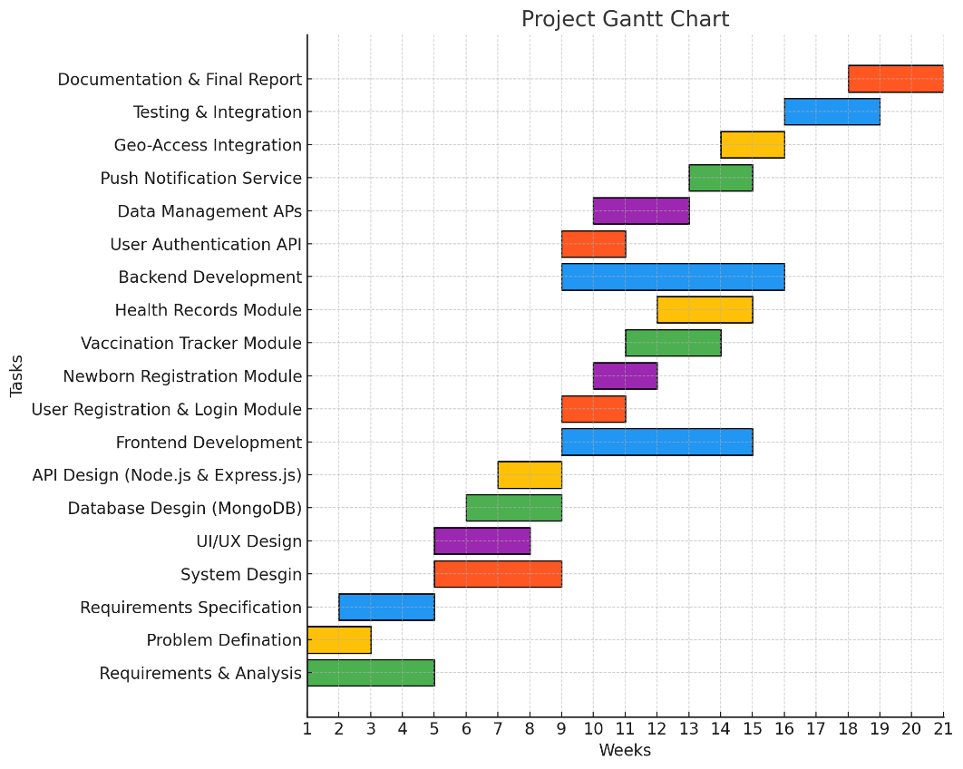
Task ID | Task Name | Start Date | End Date | Status
T1 | Requirements & Analysis | Week 1 | Week 4 | Completed
T1.1 | Problem Definition | Week 1 | Week 2 | Completed
T1.2 | Requirement Specification | Week 2 | Week 4 | Completed
T2 | System Design | Week 5 | Week 8 | In Progress
T2.1 | UI/UX Design (Figma) | Week 5 | Week 7 | Completed
T2.2 | Database Design (MongoDB) | Week 6 | Week 8
T2.3 | API Design (Node.js & Express.js) | Week 7 | Week 8
T3 | Frontend Development | Week 9 | Week 14 | Completed
T3.1 | User Registration & Login Module | Week 9 | Week 10 | Completed
T3.2 | Newborn Registration Module | Week 10 | Week 11
T3.3 | Vaccination Tracker Module | Week 11 | Week 13
T3.4 | Health Records Module | Week 12 | Week 14
T4 | Backend Development | Week 9 | Week 15 | In Progress
T4.1 | User Authentication API | Week 9 | Week 10
T4.2 | Data Management APIs | Week 10 | Week 12
T4.3 | Push Notification Service | Week 13 | Week 14
T4.4 | Geo-Access Integration | Week 14 | Week 15
T5 | Testing & Integration | Week 16 | Week 18 | Not Started
T6 | Documentation & Final Report | Week 18 | Week 20 | Not Started

PERT Chart – Sem V

A PERT (Program Evaluation and Review Technique) chart helps to analyze the tasks involved in completing a project and the time needed to complete each task.
Assumptions:
- A: Requirements & Analysis (4 weeks)
- B: System Design (4 weeks)
- C: Frontend Development (6 weeks)
- D: Backend Development (7 weeks)
- E: Testing & Integration (3 weeks)
- F: Documentation & Final Report (3 weeks)
Dependencies:
- A must be completed before B.
- B must be completed before C and D.
- C and D must be completed before E.
- E must be completed before F.
The Critical Path (the longest sequence of dependent tasks) is A -> B -> D -> E -> F, with an estimated duration of 4 + 4 + 7 + 3 + 3 = 21 weeks.

3.4 Software and Hardware Requirement
The following resources are required for the development and operation of the 'Kavach' application.
3.4.1 Hardware Requirements
- Development Machine: A standard laptop or desktop computer with a minimum of an Intel i5 or equivalent processor, 8 GB of RAM, and 500 GB of SSD storage.
- Mobile Devices: Physical Android and iOS devices for comprehensive testing of the application's features and UI.
3.4.2 Software Requirements
- Operating System: Windows 10/11, macOS, or a Linux distribution.
- Development Environment: Visual Studio Code with relevant extensions, Android Studio for Android emulator, and Xcode for iOS simulator.
- Backend: Node.js runtime environment (LTS version) and npm package manager.
- Database: Firebase Firebase (cloud-hosted, NoSQL database).
- Third-Party Services: Firebase for authentication and cloud messaging, Google Maps API for geolocation services.
- Collaboration Tools: Git version control system and a GitHub repository.
- Design Tools: Figma for UI/UX prototyping.

Chapter 4 System Design

4.1 Basic Modules
The 'Kavach' mobile application is designed with a modular architecture, where each module handles a specific set of functionalities. This approach simplifies development, testing, and maintenance.
- Authentication Module: Handles user registration, login, and secure session management for both parents and healthcare providers. It ensures that only authenticated and authorized users can access the application's features.
- Profile Management Module: Allows users to create, view, and update their personal profiles. This includes parent information and a detailed profile for each registered child.
- Vaccination Tracker Module: This is the core module for tracking vaccination schedules. It manages the list of all vaccines, their due dates, and the history of administered doses. It is responsible for triggering notifications.
- Health Records Module: Manages all medical documents and reports. This includes prescriptions, lab reports, and doctor's notes, which can be uploaded and stored securely.
- Geo-Access Module: Integrates with the Google Maps API to provide location-based services. It enables users to search for nearby healthcare facilities and vaccination centers.
- Notification Module: A backend service that sends timely push notifications to users for vaccine reminders and upcoming appointments.

4.2 Data Design (Table Design)
The data design defines the structure and relationships of the information stored in the Firebase database

4.2.1 Schema Design
The database is designed with a document-based schema, leveraging the flexibility of MongoDB. The main collections are users and children, with embedded documents for related data.
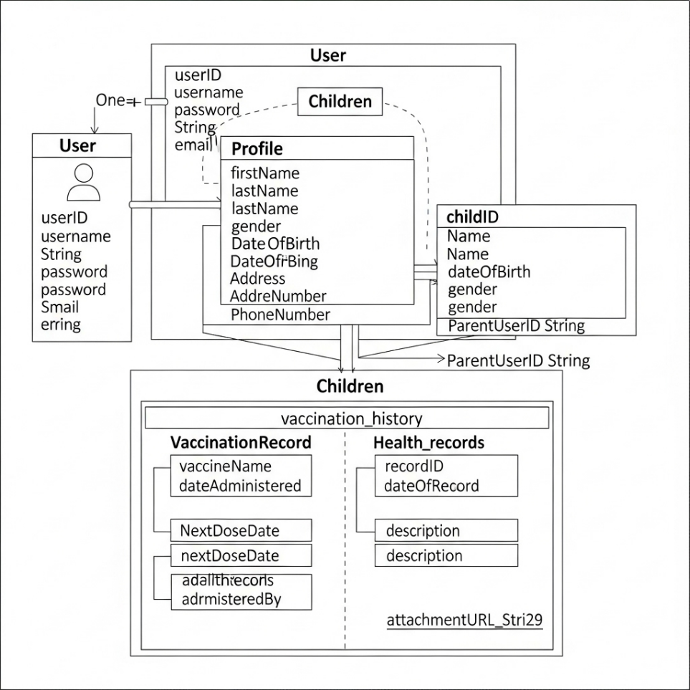
Users Collection:
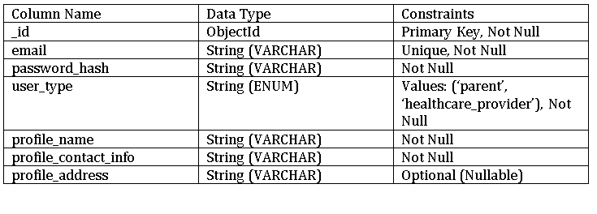
Children Collection:
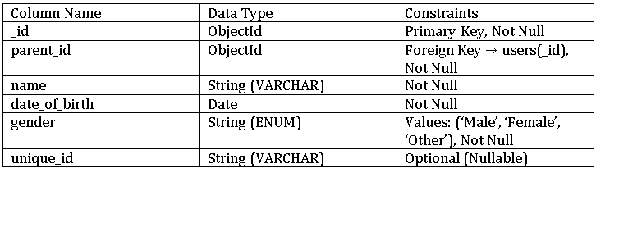
Vaccination_History: Array of Objects
Column Name | Data Type | Constraints
Vaccine_name | String (VARCHAR) | Not Null
Date_administered | Date | Not Null
Administered_by | String (VARCHAR) | Reference to healthcare_provider

o Health_Records: Array of Objects
Column Name | Data Type | Constraints
Record_type | String (VARCHAR) | Not Null
Date | Date | Not Null
Notes | String (Text) | Optional
File_Url | String (VARCHAR) | Must be a valid URL (link to stored file, e.g., Firebase), Not Null

4.2.2 Data Integrity and Constraints
• email: Must be unique in the users collection.
• parent_id: A child document must have a valid parent_id that references a user document of type parent.
• Required Fields: Critical fields such as _id, name, email, and date_of_birth are mandatory.
• Data Types: Data types are strictly enforced to ensure consistency (e.g., Date for dates, String for text)

4.3 Diagrams
The following diagrams visually represent the system's architecture and flow.

4.3.1 E-R Diagram /Block Diagram
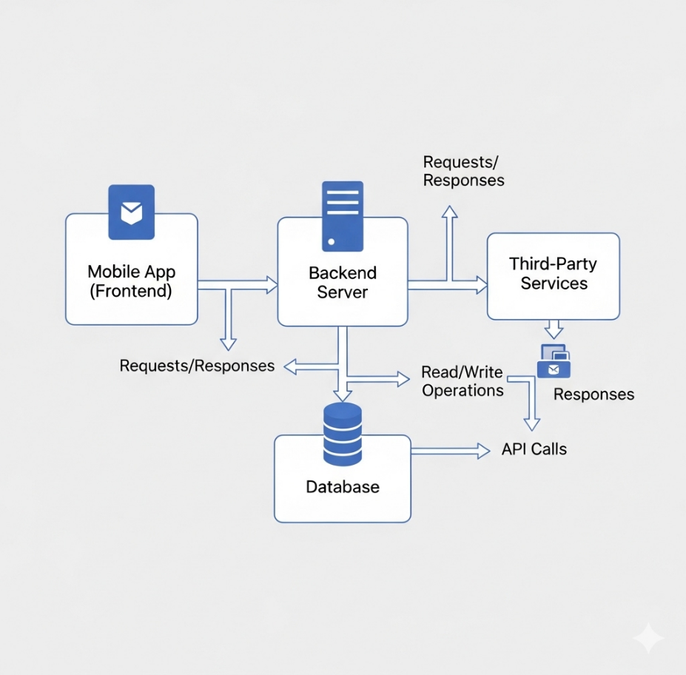
The block diagram shows the high-level components and their interactions. It illustrates the client-server architecture with the mobile app (frontend), the backend server, the database, and third-party services.

4.3.2 Class Diagram / Data Flow Diagram
The class diagram shows how Parents, Doctors, and Hospitals interact with Newborn records, while Vaccination and HealthRecord classes ensure systematic health tracking. Admin oversees the system’s integrity.
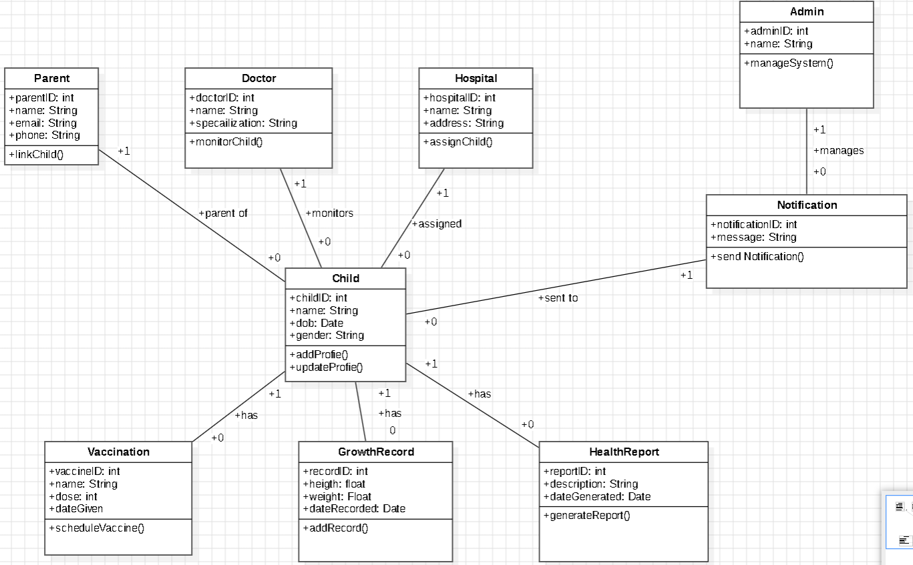

The DFD shows how data moves through the system.
Level 0: Context Diagram: Shows the entire system as a single process with external entities (Parent, Healthcare Provider) and the flow of data.
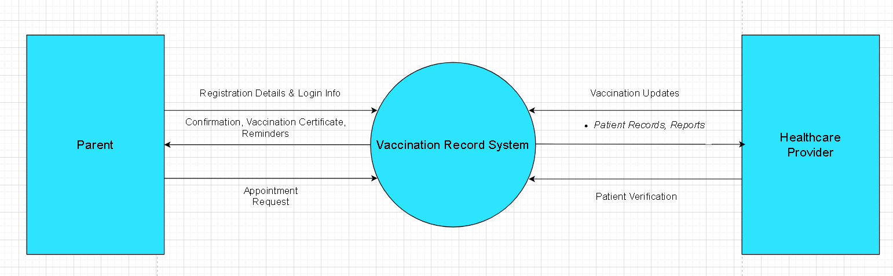
Level 1: System-level DFD: Breaks down the system into major processes, such as User Authentication, Record Management, and Vaccination Tracking, showing data stores and data flows between them.
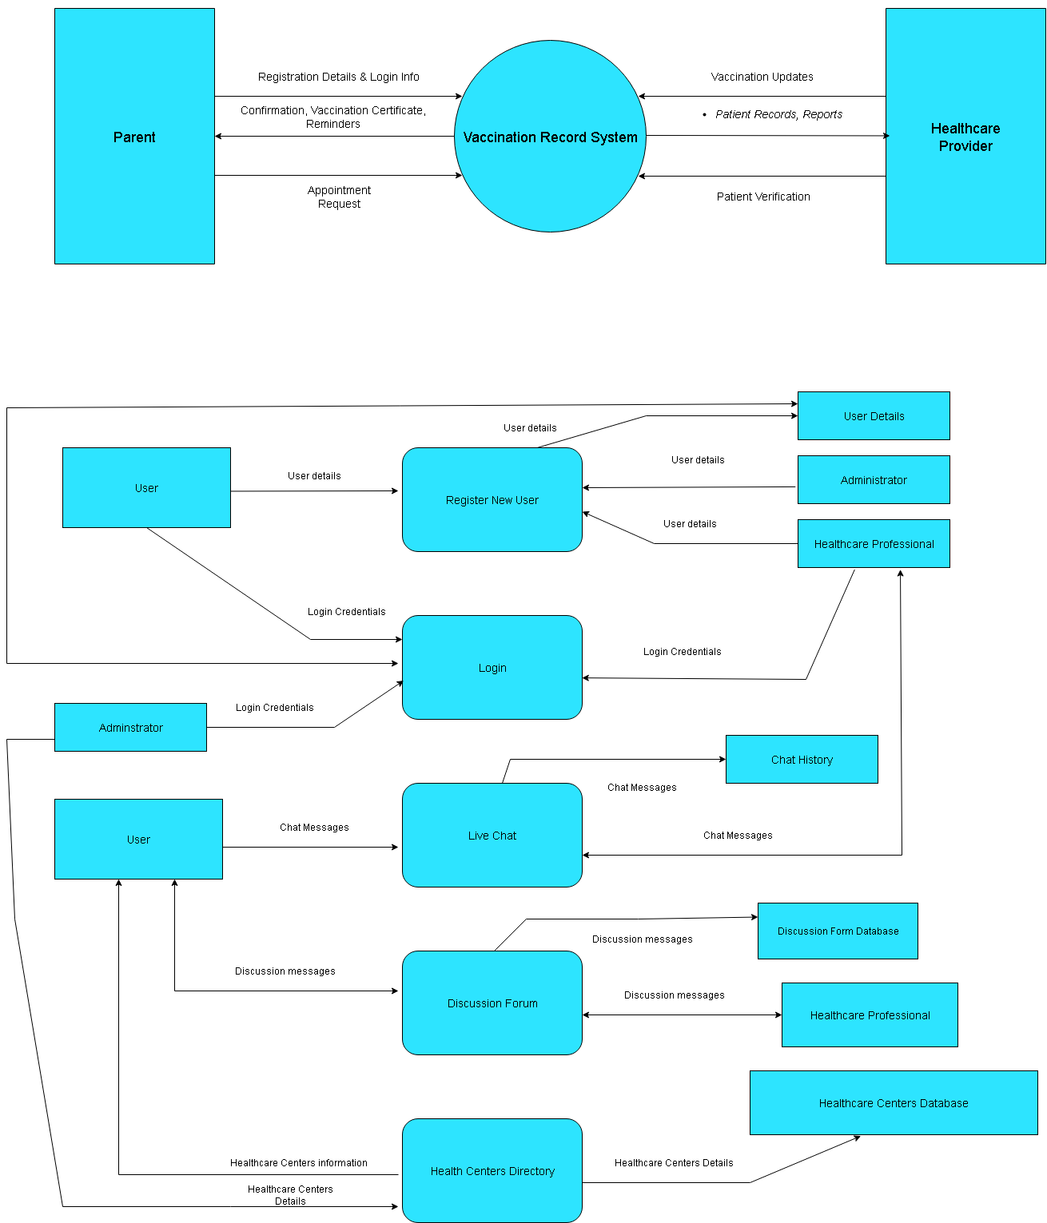

4.3.3 Use Case Diagram
The use case diagram describes the functions of the system from the user's perspective. It shows the main actors (Parent, Healthcare Provider) and the use cases they perform (e.g., Register Child, Track Vaccination, View Records).
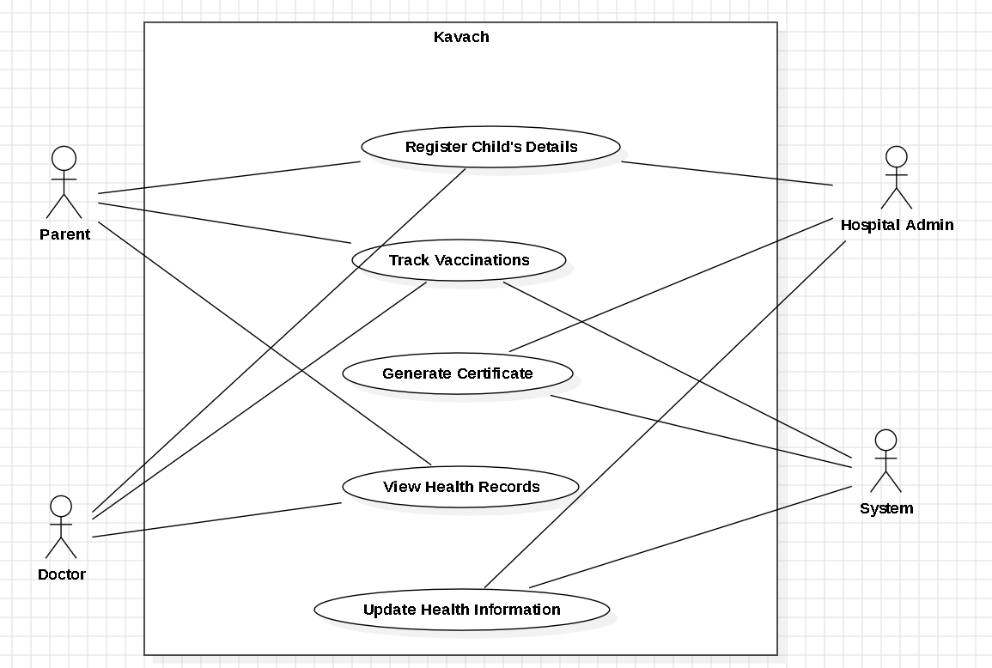

4.3.4 Sequence Diagram
A sequence diagram illustrates the interactions between objects in a sequential order. This diagram can show the flow for a specific scenario, such as "Parent registers a new child."
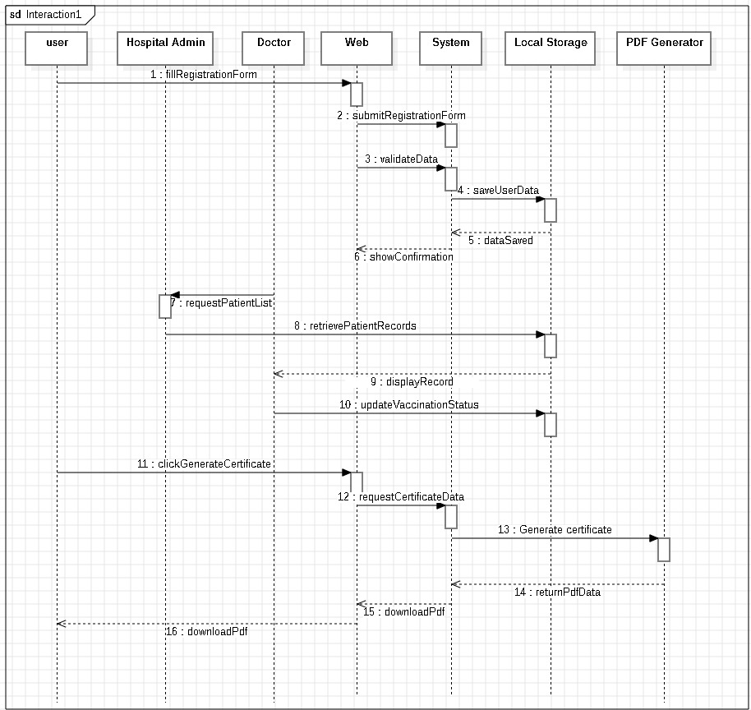

4.3.5 Activity Diagram
An activity diagram models the flow of control and actions within a process. It can be used to show the workflow for a process like "Adding a new health record."
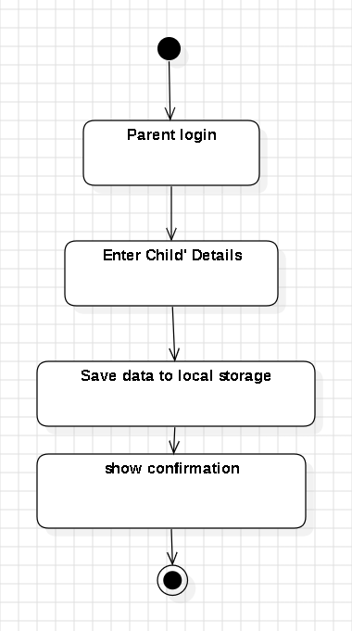

4.3.6 Component Diagram
The component diagram shows the structural relationship between software components of the system.
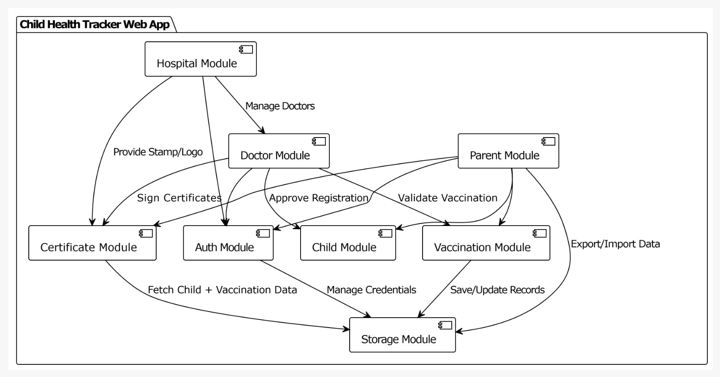

4.3.7 Menu Tree / Circuit Diagram
A menu tree provides a hierarchical representation of the application's navigation flow.
1. Home / Dashboard
├─ Overview / Stats
├─ Total Children Registered
├─ Vaccinations Completed
├─ Upcoming Vaccinations
├─ Quick Actions
├─ Register Child
├─ Generate Certificate
├─ View Recent Activity

2. Users
├─ Doctors
├─ Register Doctor
├─ Doctor List
├─ Edit Doctor Details
├─ Parents
├─ Register Parent
├─ Parent List
├─ Edit Parent Details
├─ Children
├─ Register Child
├─ Child List
├─ Edit Child Details

3. Vaccinations
├─ Vaccination Schedule
├─ View Schedule
├─ Edit Schedule
├─ Track Vaccination
├─ Record Vaccination
├─ View Vaccination History
├─ Upcoming Vaccinations

4. Certificates
├─ Generate Certificate
├─ Select Child
├─ Select Vaccine(s)
├─ Preview Certificate
├─ Download PDF
├─ Certificate History
├─ View Past Certificates

5. Reports / Analytics
├─ Children Report
├─ Filter by Age / Vaccination Status
├─ Vaccination Report
├─ Completed vs Pending
├─ Doctor Activity
├─ Vaccinations Administered

6. Settings
├─ Profile
├─ Edit User Info
├─ Change Password
├─ App Settings
├─ Notification Preferences
├─ Data Backup / Restore

7. Help / Support
├─ FAQ
├─ Contact Support
├─ About the App

4.3.8 Event Table
An event table documents the events that trigger system actions and the responses.

Event  ID | Event Description | Trigger | Response
E1 | User (doctor/parent/hospital) registers | Register button | Save user details in browser storage
E2 | User logs in | Login button | Redirect to dashboard
E3 | Parent/doctor adds child details | Save button | Save child details in browser storage
E4 | Vaccination details are added/updated | Save button | Show reminder notification in app
E5 | System tracks due vaccination | Due date | Notification appears in app and on device
E6 | User generates vaccination certificate | Generate button | Certificate generated and available for PDF download

4.3.9 User Interface Design
The UI design is a critical part of the system design. It ensures the application is intuitive and user-friendly. The design mockups, created using Figma,Lovable.dev show the layout, colors, typography, and interactive elements for each screen.

4.3.10 Security Issues
This section identifies potential security risks and the measures taken to mitigate them.
- Unauthorized Access: Use Firebase Authentication and secure API endpoints to ensure only authorized users can access data.
- Data Encryption: Encrypt sensitive data (e.g., health records) both in transit (using HTTPS/SSL) and at rest (using database encryption features).
- SQL Injection / NoSQL Injection: Validate and sanitize all user input to prevent malicious queries.
- Cross-Site Scripting (XSS): Ensure all data displayed to the user is properly escaped.

4.3.11 Test Cases Design
Test Case ID | Test Case Description | Expected Result
UC-001 | Test user registration | User is successfully registered
UC-002 | Test user login | User is successfully logged in
UC-003 | Test add vehicle | Vehicle is successfully added
UC-004 | Test add maintenance record | Maintenance record is successfully added
UC-005 | Test add mileage record | Mileage record is successfully added
UC-006 | Test notification | Notifications are displayed
UC-007 | Test settings | Settings are updated and saved
UC-008 | Test error handling | Error messages are displayed
UC-009 | Test security features | Security features are implemented
UC-010 | Test performance | App performs well with large datasets

Test cases are designed to verify that the application meets all the specified requirements. Each test case includes a scenario, a set of actions, and an expected outcome.
- Test Case 1: User Registration
  - Scenario: A new parent registers for an account.
  - Action: Open the app, navigate to the registration screen, enter a valid email and password, and tap "Sign Up."
  - Expected Outcome: The user is successfully registered, logged in, and redirected to the home screen. A new user document is created in the users collection.
- Test Case 2: Vaccination Reminder
  - Scenario: A child has a vaccine due next week.
  - Action: Wait for the scheduled notification time.
  - Expected Outcome: A push notification is received on the parent's device with the vaccine name and due date.

References

It is very important that the students acknowledge the work of others that they have used or adapted in their own work, or that provides the essential background or context to the project. The use of references is the standard way to do this. Please follow the given standard for the references for books, journals, and online material. The citation is mandatory in both the reports.
E.g:
Linhares, A., & Brum, P. (2007). Understanding our understanding of strategic scenarios: What role do chunks play? Cognitive Science, 31(6), 989-1007. https://doi.org/doi:10.1080/03640210701703725
Lipson, Charles (2011). Cite right : A quick guide to citation styles; MLA, APA, Chicago, the sciences, professions, and more (2nd ed.). Chicago [u.a.]: University of Chicago Press. p. 187. ISBN 9780226484648.
Elaine Ritchie, J Knite. (2001). Artificial Intelligence, Chapter 2 , p.p 23 - 44. Tata McGrawHill.

Bibliography

1.https://pmc.ncbi.nlm.nih.gov/articles/PMC10785842/

Website Used
https://www.google.com/chrome/
https://gemini.google.com/
https://github.com/
https://www.figma.com/
https://www.perplexity.ai/
https://www.meta.ai/

Glossary
Child Health Tracker Web App Glossary:

1. User Registration: Process of signing up and creating a profile for doctors, parents, and hospitals to access the app.
2. Vaccination Tracking: Monitoring and recording vaccination status for each child, including dates and types of vaccines administered.
3. Certificate Generation: Creating digital certificates based on vaccination records, which can be downloaded as PDFs.
4. Browser Storage: Storing data locally in the user's web browser, allowing for quick access and potentially improving performance.
5. PDF Download: Saving generated certificates as Portable Document Format (PDF) files, which can be easily shared or stored.
6. Child Health Records: Collection of data related to a child's health, including vaccination history, medical history, and contact information.
7. User Roles: Different levels of access and permissions assigned to users, such as doctors, parents, and hospital administrators.
8. Data Security: Measures taken to protect sensitive health data from unauthorized access, use, or disclosure.
9. Authentication: Process of verifying user identities to ensure secure access to child health records.
10. Health Tracker: A digital tool that helps monitor and manage child health information, including vaccination records and medical history..

Appendices

Appendix A — Core Features
- Account registration for doctors, parents, hospitals, and children.
- Vaccination schedule tracking and real-time status updates.
- Local storage of all health records and user data via browser technologies.
- Integrated PDF certificate generation for vaccinations.
- User-friendly forms for data entry and update.

Appendix B — Functional Modules
- Registration forms: children, parents, doctors, hospitals.
- Vaccination dashboard with schedules, upcoming doses, and completion status.
- PDF creation libraries (jsPDF, PDFMake) for browser-based certificate downloads.
- Data storage management using localStorage/IndexedDB, with guidance on import/export.
- Role-based access and notification settings (parents, doctors, staff).

Appendix C — Implementation Notes
- Use of modern web stack (HTML5, CSS3, JavaScript/TypeScript, React/Vue/Angular).
- Data privacy best practices and limits of local browser storage.
- Offline access capability for health records and certificate generation.
- Certificate authenticity enhancements: embedding QR codes, unique IDs.

Appendix D — User Roles & Access
- Parent features: child registration, viewing vaccination status, downloading certificates.
- Doctor features: update records, certify vaccinations, manage profiles.
- Hospital/admin features: data oversight, auditing, and support.

Summary

The child health tracker web app is a browser-only solution for doctors, parents, and hospitals to register child profiles, monitor vaccination schedules, and generate downloadable PDF certificates—all information is stored securely in the browser for quick and private access. The app’s intuitive forms and dashboards support easy registration, real-time immunization updates, and role-based access for medical professionals and parents.

Further Reading

Books:
- "Flutter in Action" by Eric Windmill - A comprehensive guide to building Flutter applications.
- "Appwrite in Action" by Santi Santillan - A guide to building Appwrite applications.
- "Google Maps API in Action" by Santi Santillan - A guide to using the Google Maps API.
- "Vehicle Maintenance and Repair" by Chilton - A comprehensive guide to vehicle maintenance and repair.
- "Designing Data-Intensive Applications" by Martin Kleppmann (O'Reilly Media, 2017)
Research Papers:
- "A Study on Vehicle Maintenance and Repair" by Journal of Automotive Engineering
- "A Study on the Use of Mobile Apps for Vehicle Maintenance and Repair" by Journal of Mobile Computing
- "A Study on the Impact of Vehicle Maintenance and Repair on the Environment" by Journal of Environmental Science

Plagiarism Report

